**Project 4**

**Online Test Application**

-Abhishek Gangwar

**Project Overview**

The quiz application consists of mainly 1 components/views: exam, for the sake of simplicity.

This system contains three main modules: Quiz, Review, and Result.

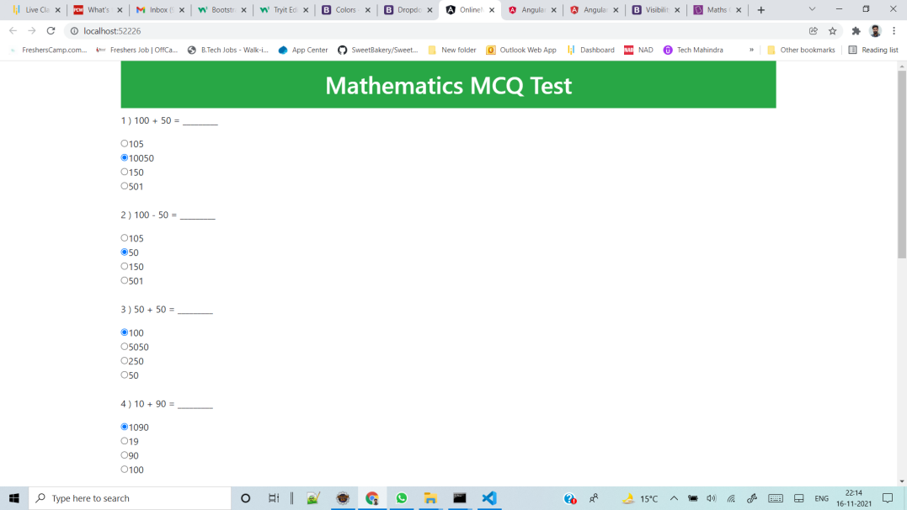

Once user will submit he exam, the exam will get submitted and result will appear.

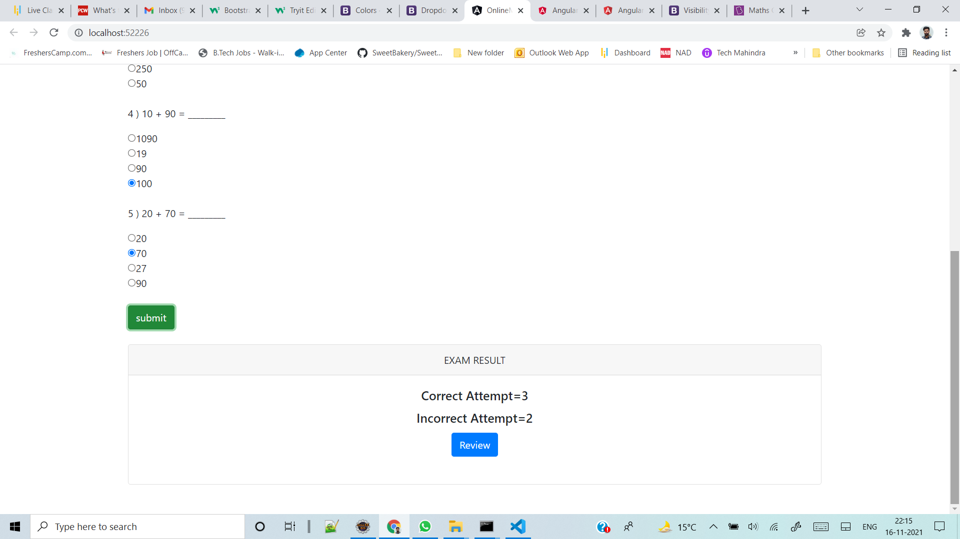

The “Review” section allows users to declare the Review he exam 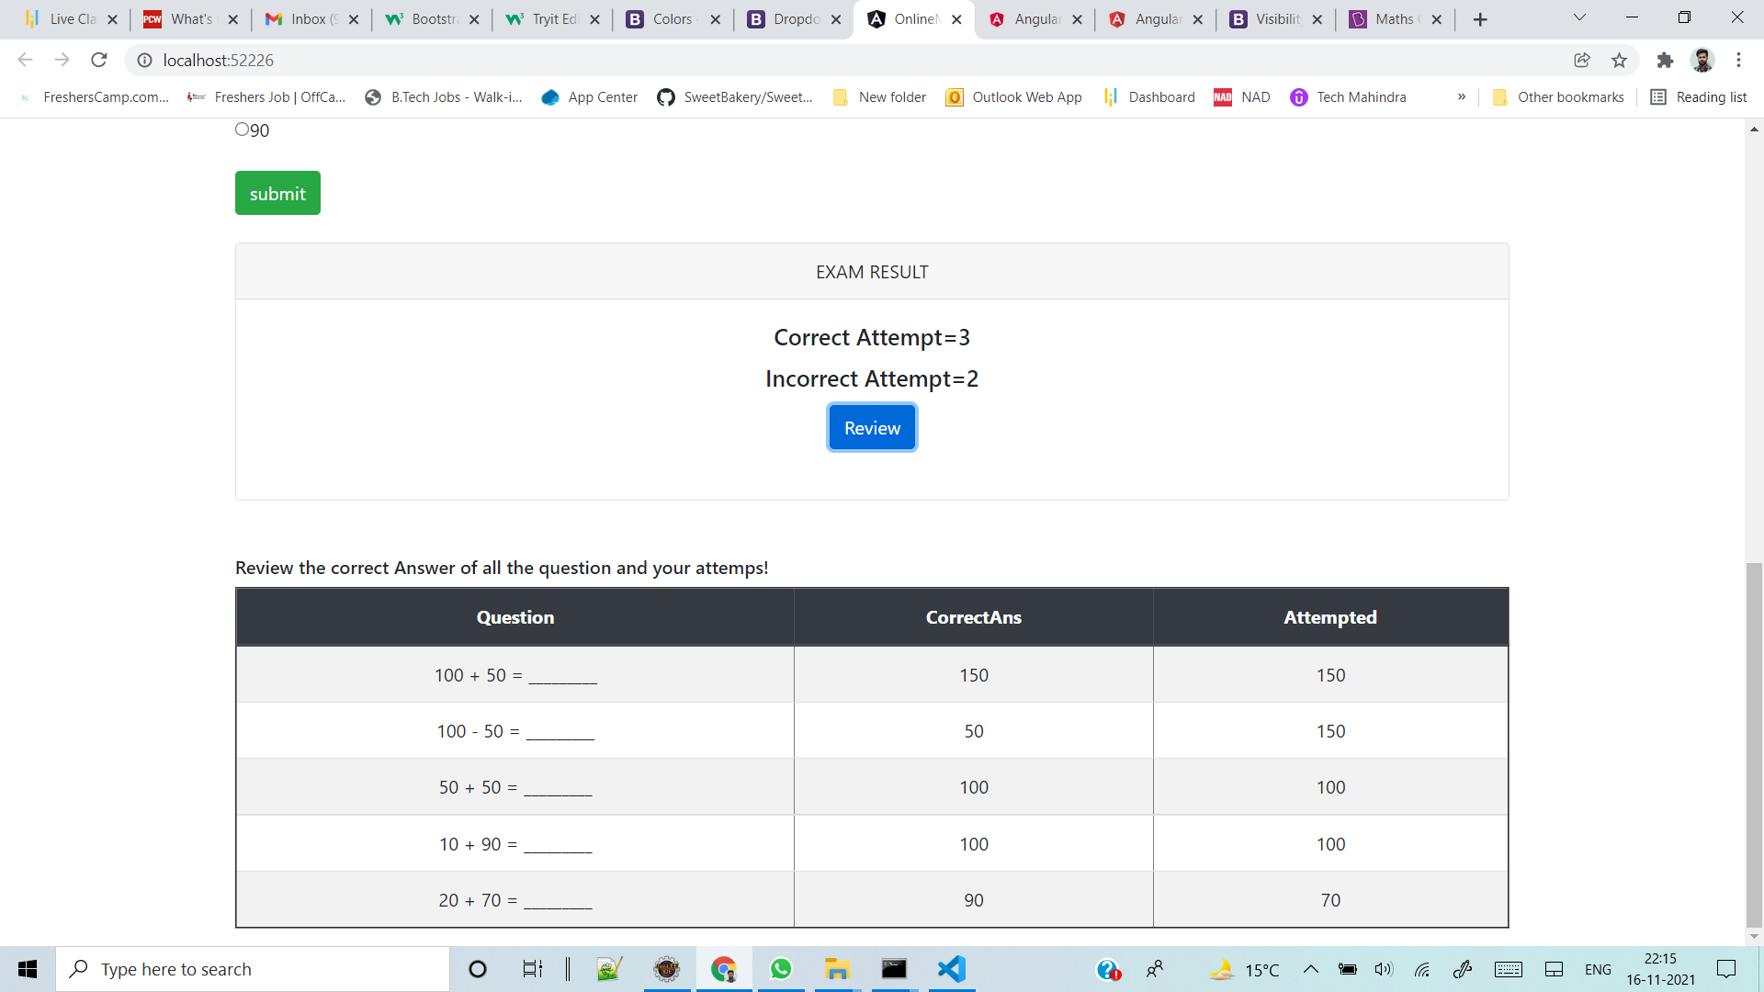

**Technology Used**

Angular, typescript,html5, css3, Bootstrap